2015 PRESS KIT

Media Contact
Rebecca von Goetz
Senior Marketing & Communications Specialist
Profound Medical Corp
3080 Yonge Street, Suite 4040
Toronto, Ontario, Canada
M4N 3N1

rvongoetz@profoundmedical.com
T 647.476.1350, Ext. 426

About Profound Medical Corp.
Profound Medical is a medical device company that has developed a unique and minimally invasive treatment to ablate the prostate gland. Profound’s novel technology combines MR imaging with ultrasound thermal energy that is delivered via a transurethral approach. This investigational method of prostate ablative therapy provides highly accurate and precise treatment of the prostate in a short time span, allowing for fast patient recovery. The potential of this technology is currently being assessed in clinical trials. For more information, visit profoundmedical.com

Profound Medical Corp. Background Information
TULSA
http://www.profoundmedical.com/tulsa

Management Team
http://www.profoundmedical.com/about-us/#managementTeam

Board of Directors
http://www.profoundmedical.com/about-us/#board

Clinical Advisory Board
http://www.profoundmedical.com/about-us/#clinical

TULSA vs. HIFU insert
Insert pdf

A Profoundly Different Way to Ablate Prostate Cancer brochure
Brochure.pdf

Images

Procedure Illustrations
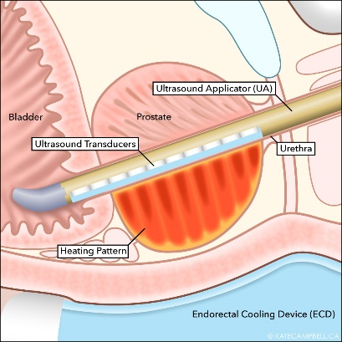

Images
(continued)

Thermal Ablation TULSA-PRO device
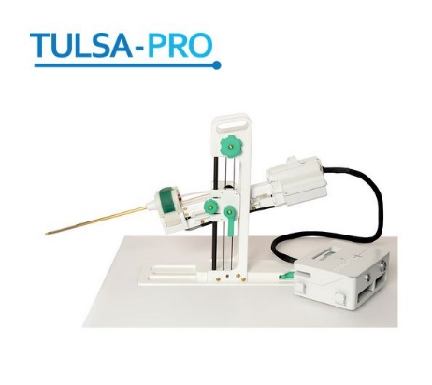

Frequently Asked Questions
Q. What does TULSA stand for?
A. Transurethral Ultrasound Ablation

Q. What is TULSA-PRO?
A. TULSA-PRO is the medical device. TULSA is the procedure.

Q. Does the procedure treat prostate cancer?
A. The procedure is for patients with localized, organ-confined prostate cancer. TULSA is used to ablate the prostate gland, including cancerous tissue.

Q. How does TULSA differ from HIFU?
A. TULSA delivers a continuous volume of thermal ablation in a 360° sweep from the inside-out. Treatment is MRI-guided and delivered under real-time active temperature feedback control. Treatment time is less than 40 minutes for the average sized prostate and patients go home within 24 hours of the procedure. TULSA has the potential for fewer significant complications.

Q. Is the procedure currently available?
A. No, the procedure is not yet available to patients. We are currently launching a 110 patient Pivotal Trial. We plan to commercialize in Europe and Canada in 2016, in the U.S. in 2017.

Q. Profound Medical became a public company in June 2015. Where can I find the current share price?
A. The current share price can be found by searching for the ticker symbol “PRN” at http://web.tmxmoney.com/quote.php?qm_symbol=PRN

Profound Medical Social Media Channels
www.linkedin.com/company/profound-medical-inc

www.youtube.com/results?search_query=profound+medical

104560A Investigational device. Limited by federal law for investigational use.

