PRESS KIT

Media Contact
Sanam Riahi
Marketing Director
Profound Medical Corp
2400 Skymark Avenue, Unit #6
Mississauga, Ontario, Canada
L4W 5K5

sriahi@profoundmedical.com
T 647.476.1350, Ext. 439

About Profound Medical Corp.
Profound Medical is a Canadian medical device company that has developed a unique and minimally invasive treatment to ablate the prostate. Profound’s novel technology combines real-time MR imaging with transurethral, robotically-driven therapeutic ultrasound and closed-loop thermal feedback control. It provides a highly precise treatment tailored to patient-specific anatomy and pathology. This method of prostate ablation offers short treatment times and low morbidity, allowing for fast patient recovery. For more information, visit profoundmedical.com

Profound Medical Corp. Background Information
MRI-Guided TULSA
http://www.profoundmedical.com/tulsa

Management Team
http://www.profoundmedical.com/about-us/#managementTeam

Board of Directors
http://www.profoundmedical.com/about-us/#board

Clinical Advisory Board
http://www.profoundmedical.com/about-us/#clinical

Brochure – An Inside Out Approach to Prostate Ablation.pdf

Phase 1 Clinical Trial Results Presentation 2015.pdf

News
http://www.profoundmedical.com/newsroom/

Images

The Procedure Heating Pattern
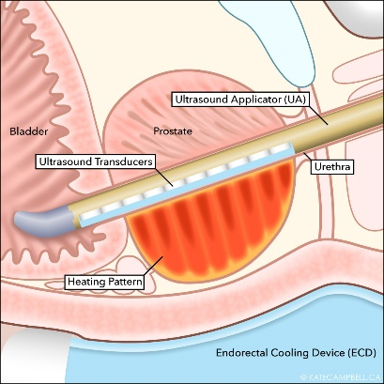

Images
(continued)

Thermal Ablation TULSA-PROTM device
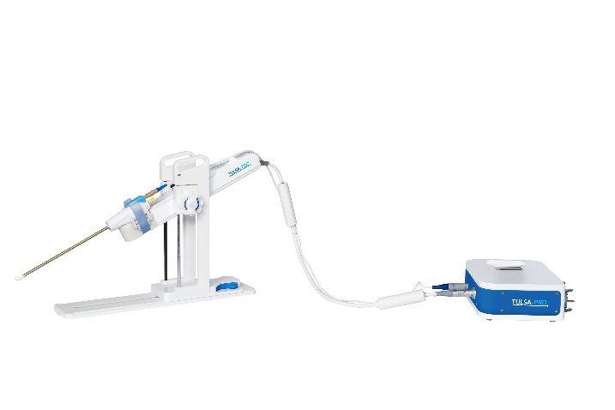

Frequently Asked Questions
Q. What does TULSA stand for?
A. Transurethral Ultrasound Ablation

Q. What is TULSA-PROTM?
A. TULSA-PRO™ is the medical device. MRI-Guided TULSA is the procedure.

Q. Does the procedure treat prostate cancer?
A. The procedure is for patients with localized, organ-confined prostate cancer. TULSA-PRO™ is used to ablate the cancerous and non-cancerous prostate tissue.

Q. How does MRI-Guided TULSA differ from HIFU?
- MRI-Guided TULSA uses a transurethral approach, ablating the prostate from the inside-out. HIFU is transrectal, and focuses the ultrasound energy from the outside-in, through the rectal wall which is the exact tissue you want to avoid heating.
- TULSA is MRI-guided from treatment planning through to treatment assessment. Most importantly, MRI thermometry provides real-time quantitative temperature measurements within the prostate, allowing closed-loop active temperature feedback control of the ablation volume. HIFU does not have temperature feedback control.

- MRI-Guided TULSA delivers directional but not focused ultrasound directly to the prostate gland, ensuring a contiguous ablation volume with no cold spots between sonications. This also allows a larger volume of tissue to be heated in a short amount of time, ultimately resulting in short treatment times of approximately 40 minutes. HIFU, on the other hand, scans discrete focal areas of ablation across the prostate in a sequential fashion. Overlap between these discrete sonications is important to avoid cold spots, and ultimately results in long treatment times of approximately 3 hours.

Q. Is the procedure currently available?
A. Yes. TULSA-PRO™ currently has CE mark approval and is available commercially in Europe. The product does not yet have regulatory approval in North America.

Q. Profound Medical became a public company in June 2015. Where can I find the current share price?
A. The current share price can be found by searching for the ticker symbol “PRN” at http://web.tmxmoney.com/quote.php?qm_symbol=PRN

Profound Medical Social Media Channels
www.linkedin.com/company/profound-medical-inc

www.youtube.com/results?search_query=profound+medical

TULSA-PROTM has CE Marking. Regulatory Authorization is pending for all other jurisdictions.

